LangGraph case study

FOLDERS:
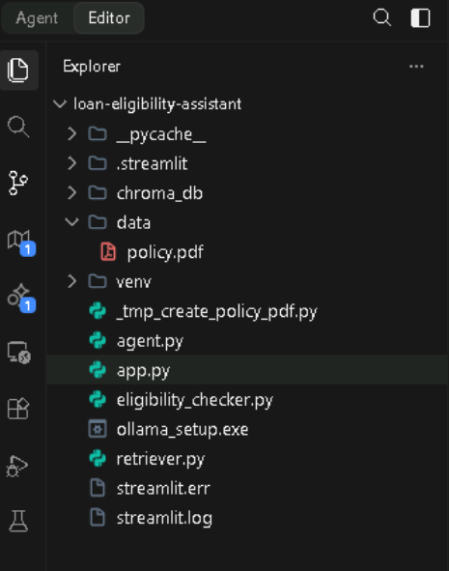
venv/: This is virtual environment folder. It contains the specific Python interpreter and all the libraries (like LangChain, Streamlit, and Ollama) required for your project to run without interfering with other software on your computer.
data/: This directory stores private documents, such as policy.pdf. The retriever.py script looks here to load the documents that the AI will use to answer policy-related questions.
agent.py: This is the "brain" of project. It initializes the local LLM (via Ollama), defines the tools (eligibility checker and retriever), sets up the memory, and constructs the agent that decides how to respond to users.
eligibility_checker.py: This file contains the business logic for evaluating loan applications. It applies specific rules—such as minimum age, salary, and credit score requirements—to determine if an applicant is eligible.
retriever.py: This script handles the RAG (Retrieval-Augmented Generation) process. It loads the PDF, splits it into chunks, converts them into embeddings, and stores them in a vector database (ChromaDB) so the agent can perform semantic searches.
app.py: This is your frontend interface. It uses the Streamlit framework to create a web-based chat window, allowing to interact with agent in a browser.
.env: (If present) This file is used to store sensitive configuration details, such as API keys if we were using an external service like OpenAI. Since we are using a local model with Ollama, this file may not be strictly required anymore.

CODE:
agent.py:

from langchain_ollama import ChatOllama
from langchain_classic.agents import AgentExecutor, create_tool_calling_agent
from langchain_core.prompts import ChatPromptTemplate, MessagesPlaceholder
from langchain_core.tools import tool
from langchain_classic.tools.retriever import create_retriever_tool
from langchain_classic.memory import ConversationBufferMemory
from eligibility_checker import check_eligibility
from retriever import get_retriever

@tool
def eligibility_tool(applicant_data: dict):
"""Useful for checking if a customer is eligible for a loan."""
return check_eligibility(applicant_data)

retriever = get_retriever()
policy_tool = create_retriever_tool(
retriever,
"loan_policy_search",
"Searches for bank loan eligibility policy documents."
)

tools = [eligibility_tool, policy_tool]
llm = ChatOllama(model="llama3.1", temperature=0)

prompt = ChatPromptTemplate.from_messages([
("system", "You are a helpful loan assistant."),
MessagesPlaceholder(variable_name="chat_history"),
("human", "{input}"),
MessagesPlaceholder(variable_name="agent_scratchpad"),
])

memory = ConversationBufferMemory(
memory_key="chat_history",
return_messages=True
)

agent = create_tool_calling_agent(llm, tools, prompt)

agent_executor = AgentExecutor(
agent=agent,
tools=tools,
verbose=True,
memory=memory
)

print("System initialized with automatic conversation memory.")

app.py:

import streamlit as st
from agent import agent_executor

st.set_page_config(page_title="Loan Eligibility Assistant", page_icon="🏦", layout="wide")

with st.sidebar:
st.title("🏦 Agent Settings")
if st.button("Clear Conversation History"):
st.session_state.messages = []
st.rerun()
st.markdown("---")
st.info("This assistant uses local Llama 3.1 for secure, private loan policy analysis.")

st.title("💰 Loan Eligibility Assistant")

if "messages" not in st.session_state:
st.session_state.messages = []

for message in st.session_state.messages:
with st.chat_message(message["role"]):
st.markdown(message["content"])

if prompt := st.chat_input("Ask about loan policies or check your eligibility..."):
st.session_state.messages.append({"role": "user", "content": prompt})
with st.chat_message("user"):
st.markdown(prompt)

with st.chat_message("assistant"):
with st.spinner("Assistant is thinking..."):
try:
response = agent_executor.invoke({"input": prompt})
result = response["output"]
st.markdown(result)
st.session_state.messages.append({"role": "assistant", "content": result})
except Exception as e:
st.error(f"An error occurred: {e}")

retriever.py:

import os

from langchain_community.document_loaders import PyPDFLoader
from langchain_community.vectorstores import Chroma
from langchain_core.documents import Document
from langchain_huggingface import HuggingFaceEmbeddings
from langchain_text_splitters import CharacterTextSplitter

def get_retriever():
pdf_path = "data/policy.pdf"
if os.path.exists(pdf_path):
loader = PyPDFLoader(pdf_path)
documents = loader.load()
else:
print(f"Warning: {pdf_path} not found. Using placeholder policy text.")
documents = [Document(page_content="No loan policy document found. Please provide data/policy.pdf.")]

if not documents:
documents = [Document(page_content="The policy document is empty. Please provide content in data/policy.pdf.")]

text_splitter = CharacterTextSplitter(chunk_size=1000, chunk_overlap=0)
texts = text_splitter.split_documents(documents)
embeddings = HuggingFaceEmbeddings()
db = Chroma.from_documents(texts, embeddings)
return db.as_retriever()

eligibility_checker.py:

def check_eligibility(applicant_data: dict):
age = applicant_data.get("age")
salary = applicant_data.get("salary")
loan_amount = applicant_data.get("loanAmount")
credit_score = applicant_data.get("creditScore")

reasons = []
if age < 21: reasons.append("Age must be >= 21")
if salary < 30000: reasons.append("Salary must be >= 30,000")
if credit_score < 700: reasons.append("Credit score must be >= 700")
if loan_amount > (10 * salary): reasons.append(f"Loan amount exceeds 10x salary (Max: {10 * salary})")

if not reasons:
return {"eligible": True, "reason": "All criteria satisfied."}
return {"eligible": False, "reason": "; ".join(reasons)}
config.toml

toml
[server]
fileWatcherType = "none"
headless = true

[browser]
gatherUsageStats = false

OUTPUT:-
